MONDAY | TUESDAY | WEDNESDAY | THURSDAY | FRIDAY | SATURDAY | SUNDAY
12/02 | 13/02 | 14/02 | 15/02 | 16/02 | 17/02 | 18/02
10.30am  Coffee and Chat in the Lifestyle Centre. All new residents welcome.  10:30am  Movie at New Acton - Phantom Thread. As this movie runs over lunch you can take or buy something to eat at the venue. If attending, please put your name on the list by Friday 9th February.  11:45am – 12:30pm  Weights & Resistance  1:30pm – 2:15pm  Tai Chi (Best Balance)  3.00pm  Come along and join in a social game of Mahjong. Beginners welcome. | 7:00am  Fast Walk  8:30am  Meet outside The District.  No booking required just turn up.  10.00am  Exercise class with Ryan  $10 a class. Everyone welcome.  11:00am  Cruise information session from Reis & James Travel Associates at the Ainslie Goodwin site. Lunch at the Goodwin café.  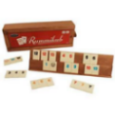  3:00pm  Come and enjoy a casual game of RUMMIKUB.  Beginners welcome. | 9:00am – 9:45am  Weights & Resistance  10:00am – 10:45am  Yoga (Strength and Stretch)  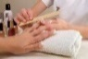  9:00am - 3:00pm  Zoiya’s Beauty Clinic@ Goodwin. Please call Zoiya from the intercom outside  Building B for access to unit 121.  Bookings to be made at Reception.  2:00pm  Sjoole (Shuffleboard) in the Activities Room. There will be lessons for any beginners.  3:00pm  Bridge sessions. Players of all levels welcome. Lessons available. | 9:30am  Men’s Shed Meeting in the Lifestyle Centre.  10:00am – 11:00am  Golf putting in the Activities Room.  N.B This outing is for My Aged Care – Social outing approved members only.  10:00am  Goodwin Community Social Outing. Trip to the National Sound & Archive and lunch  If attending, please put your name on the list.  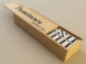  3:00pm  Come and enjoy a casual game of DOMINOES.  Beginners welcome. | 9:00am – 9:45am  Weights & Resistance  10:00am – 10:45am  Yoga (Strength and Stretch)  10:30am  Scenic drive to Boorowa and lunch at the Ex Services & Citizens Club. If attending, please put your name on the list.  Bridge Lessons  3.00pm  Mahjong.  Stay on and enjoy Happy Hour at 5:00pm.  4.00pm  Table Tennis. We have a couple of enthusiastic players who would love a few extras to join in this fun game.  5.00pm.  Happy Hour  BYO nibbles and drinks. All residents welcome. | 10.30am  Saturday Morning Coffee and Chat in the Lifestyle Centre. All new residents welcome.  2.00pm  Crafty Fingers. Why not bring your talents and have a chat in the Dining Room.  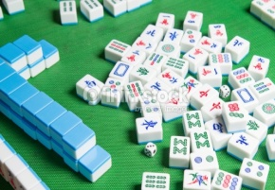  3.00pm  Come along and join in a social game of Mahjong. Beginners welome. | 11:00am  Finska in the Activities room or on the new croquet lawn. Everyone welcome.  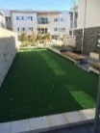  1.30pm  Croquet on the new lawn. Everyone welcome.  3:00pm  “Hit & Giggle Tennis”.

